**KING’S COLLEGE LONDON ENGINEERS’ ASSOCIATION**

**Minutes of the KCLEA Committee Meeting held on**

**22nd July 2021**

Because of the current restrictions the meeting was again held “on line”

**Those participating**

David Blacoe President

Chris Bowden Secretary

Keith Newton

Graham Raven Membership Secretary

John Thomson Treasurer and Webmaster

Jonny Dixon

Bobby Dixit Events Secretary

Lai Cheung

Nicholas St. Hill

Tiarna Lee KCLES outgoing President

Adriana Namour KCLES incoming President

Malcolm Gill Quad. Development Manager

**1)** **Apologies**

Received from Professor Shollock, Mike Clode, Ted Willis, Liz Beckmann.

**2) Approval of the minutes of the last meeting (22nd April 2021)**

Keith queried the dividends recorded under item 8) of our last meeting. These were subsequently confirmed as being correct.

**3) Developments within the Department of Engineering**

Prior to the meeting Barbara had provided the following update:-

We have finally finished the academic year with our outstanding staff and students.

We received our NSS (National Student Survey) scores and have been singled out by the Vice dean for education in the Faculty of Natural, Mathematical and **ENGINEERING** Sciences (from August!) with the following comment:

*Results for individual departments are mixed. I would, however, like to highlight one result: The Engineering department has achieved a huge improvements in results across the board, with a very significant step change improvement in almost every single measure. Even if we take the results with a grain of salt and expect some random fluctuation and effects of a variety of factors, these improvements are so significant and outstanding that there is clearly a strong and positive trend at play here. Congratulations to everyone in the Engineering department – this did not happen by chance.*

We have just published [an article on the King’s website](https://eur03.safelinks.protection.outlook.com/?url=https%3A%2F%2Fwww.kcl.ac.uk%2Fnews%2Fmeet-kings-newest-engineers&data=04%7C01%7Cbarbara.shollock%40kcl.ac.uk%7C213500fa88f14ef251fa08d94c5ad337%7C8370cf1416f34c16b83c724071654356%7C0%7C0%7C637624775227830742%7CUnknown%7CTWFpbGZsb3d8eyJWIjoiMC4wLjAwMDAiLCJQIjoiV2luMzIiLCJBTiI6Ik1haWwiLCJXVCI6Mn0%3D%7C1000&sdata=IZEYidMB52VRtZftNiP93fG4Hhx1iFTzNHxFSuwxbkQ%3D&reserved=0) with new staff profiles – we are growing- and will have new staff in the autumn which I will share.

We will enter the final stages of our admissions cycle in the second week of August but we are predicted to have more students than expected – approaching 200 new entries.

The Quad build is moving forward and I attach some photos showing recent developments both internally and externally and a view of a more populated Macadam -4 lab.

It is amazing how much has happened during these challenging times.

I attended a fundraising team meeting and they are busily working on support for the Quad.  I am most grateful for all the support of the KCLEA.  If you are happy, I will extend the meeting invitation to Malcolm Gill who chairs the committee as I raised the KCLEA donations and the importance of the KCLES- this team looks at how gifts will be displayed.

I would also like to thank our alumni community for their support of our students through the mentoring session – it was very successful and much appreciated. On behalf of the students, thank you.

**4) Quad development and “Shape the Quad Appeal”**

As this topic was raised under several agenda headings and is likely to be a key discussion and action item this separate minute item has been included. With helpful input from Malcolm Gill in attendance. the key points are:-

a) Scheduled completion date is September 2022

1. Small tours may be possible from August 2021
2. Prior to the meeting David had circulated, to the committee, a proposal which included:-
3. KCLEA donate £2000 to the appeal
4. A special edition of the Bulletin be issued on the Quad reconstruction
5. A dialogue be opened with the Engineering Department to explore how best

to capture the historical links of the KCLES

Understandably there was considerable discussion on this item. Points made and suggestions include :-

1. The positioning of the Max Lipman print to be considered.
2. The KCLES, with its history, to be remembered.
3. It was suggested that our timeline, as prepared by Keith, could be incorporated
4. It was felt that the KCLEA should be recognized on the donor wall, perhaps with a plaque. Although we are not donating the required £10,000 as a lump sum we should be recognized for the bursaries that we have given and will continue to give in the future.
5. Keith suggested that we could ask KCLEA members for personal donations, to be routed via the KCLEA
6. David suggested an edition of the Bulletin could be used to draw to the attention of alumni.
7. Further input and thoughts from all committee members to be submitted for collation

and onpass to Malcolm.

**Action G.Raven**

1. Reach out to Malcolm to get his thoughts and put out a holding note to Malcolm and Jess.

**Action B.Dixit**

1. Pull together thoughts on what KCLEA would like (to include the input from Graham, comments from other members and the input from the Department of Engineering) and discuss with Malcolm.

**Action D.Blacoe and B.Dixit**

1. The Quad Appeal ends in April 2022 so we have some time to finalize our thoughts.

A tour, as soon as possible, could help us to come up with proposals

**5) KCLEA Events**

1. **Mentoring**

Under review by Bobby and Agnes who will have further discussion as it was considered to be a good initiative that should be moved forward in terms of student needs and finding suitable mentors. One problem is that of knowing who our members are. Possibility of a sub-committee meeting, including KCLES, to agree the best way forward.

**Action B.Dixit**

1. **Annual Lunch**

Bobby advised that he is awaiting advice from Agnes as to when College Events will be able to offer catering inside the College so that we can plan a suitable date / venue.

**Action B.Dixit**

1. **Annual Lecture**

The consensus view was that we should continue with the annual lecture. Naturally the speaker and topic is important and it was considered that the following should be considered:-

1. We should have a practicing engineer and the speaker should be used to presenting lectures so that the detail is not “over people’s heads”
2. The topic needs to have a broad appeal. Suggested topics included sustainability, environmental and the future of highway systems.

Keith has as list of possible options. List to be sent to Bobby for consideration.

**Action K.Newton and B.Dixit**

**6) KCLES**

Tiarna reported that, understandably, there had been no events and the planned barbeque has been delayed, if indeed it does take place, as many students have now gone home.

An update will be provided for us at the start of the next term.

**Action A. Namour**

**7) Bursaries and Medals**

In order to move forward it was felt that the following matters need to be addressed:-

1. The need to improve awareness amongst the student community, particularly amongst

Biomedical engineering students.

1. Improve staff liaison links.
2. The possibility of linking to an event.
3. The preparation of a new bursary timetable before our next meeting.

Last year’s application details to be sent, for information, to Adriana.

**Action D.Blacoe**

**8) Finances and Investment Fund.**

Prior to the meeting John had provided KCLEA income and expenditure details. In summary:-

July 2020 to July 2021 July 2021 to June 2022

(partial)

Total income for year £1107.37 £1009.86

Total expenditure for year £2158.00 £5.60

Excess income v. expenditure -£1050.63 £1004.26

Last year’s accounts (20/21) yet to be audited and confirmed.

**Action J.Thomson**

John advised the meeting that online banking had now been set up in order to facilitate payments.

Prior to the meeting Mike had provided the following Trustees report:-

Balances held as at 30th. June 2021

2021 2020

M&G Dividend Fund £49,019.83 £40,976.69

Nationwide BS Trust a/c £11,813.75 £9,855.18

Total £60,833.58 £50,831.87

Income received 2020 to 2021

M&G Dividend Fund £1,947.69 £3,308.40 (see note)

Nationwide BS Trust a/c £10.88 £9.50

Total £1,958.57 £3,317.90

Note -- Change in dividend distribution dates inflated this amount in 2020.

Mike also provided us with the following update:-

1. *Waiting for Bursary data. College Tax Year ends 31st July so usual delay*
2. *Nationwide a/c has a £11,813.75 balance. They are still threatening to close this account which will necessitate me going to the Chiswick branch to finalise details. Nationwide are offering no help or advice.*
3. *Transfer of money from the College Bursary Funds not actioned. However we need to do something with the Nationwide balance anyway.*
4. *Tax liability status still not established. I have ventured down a number of routes to try to get this sorted but failing going to HMRC I am still in limbo. The Nationwide balance might well be needed to pay any past tax liability.*
5. *Suggest a Zoom meeting of Trustees after the minutes are published for this meeting. Monday and Tuesday are best for me but happy to try and fit in with the other Trustees.*

**Action M.Clode**

**9) Website, Membership Communication and King’s Engineer Bulletin**

It was considered that, at the moment, there was not sufficient content for an issue of the Bulletin. Mike confirmed that he is happy to put one out once content is available. Distribution would be via his old list if nothing has changed with KCLA.

**Action M.Clode and G.Raven**

**10) AOB**

None

**11) Date of next meeting.**

30th. September 2021. Arrangements to be reviewed nearer to the date

**Action C.Bowden**

**APPENDIX**

Also see separate pdf file of progress photos in July 2021

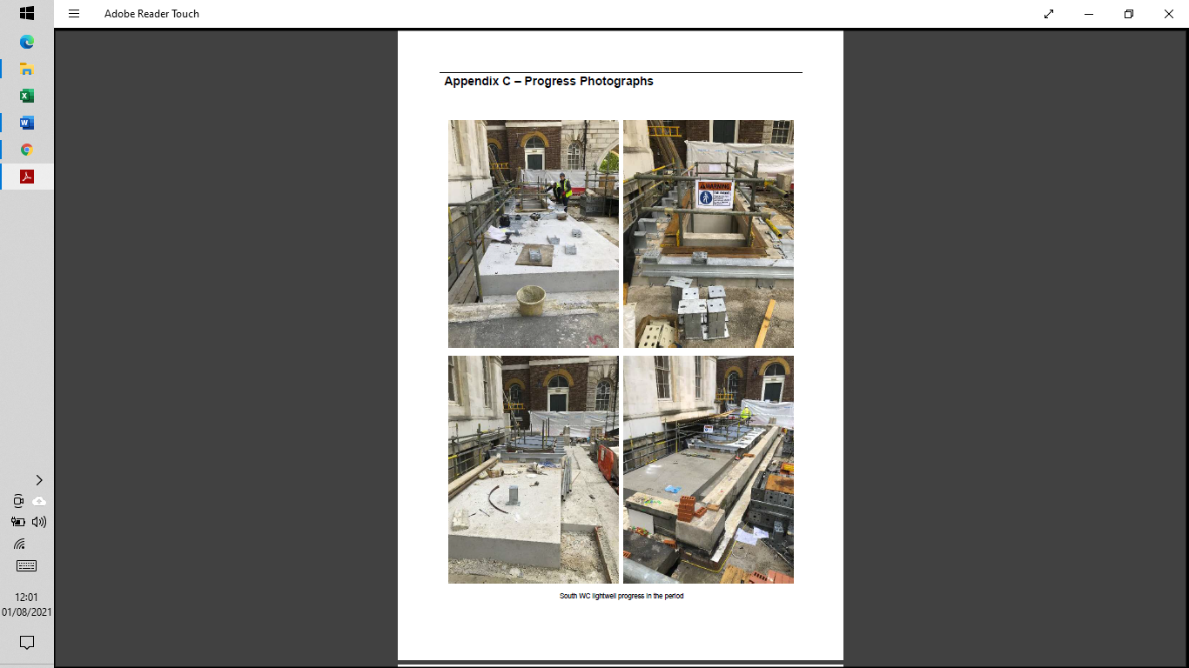**AA**

